1. List all students with a total credit count of 0.

select * from student where tot_cred>0 and rownum<10;
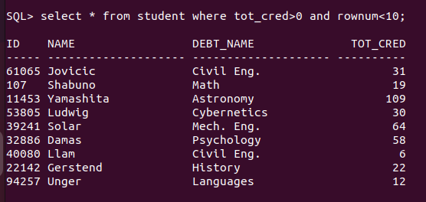

2. Find the names of all courses offered by the "Physics" department.
Select * from student where tot_cred>0 and rownum<10;
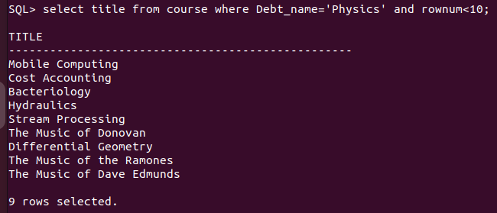
3. Retrieve the names of all instructors who earn less than ₹50,000.

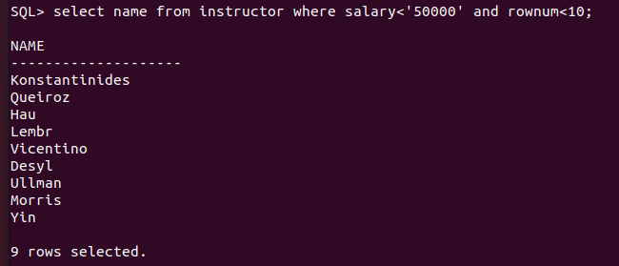

4. List all classrooms with a capacity of exactly 100.

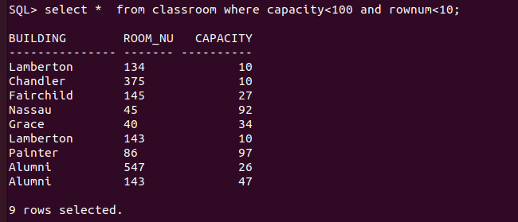

5. Find the total number of courses offered in the "Summer" semester.
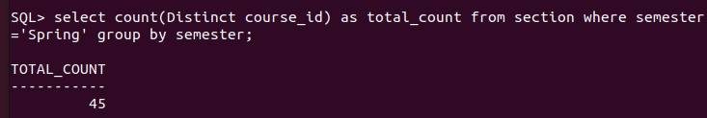

6. List all students who have taken exactly 30 total credits.

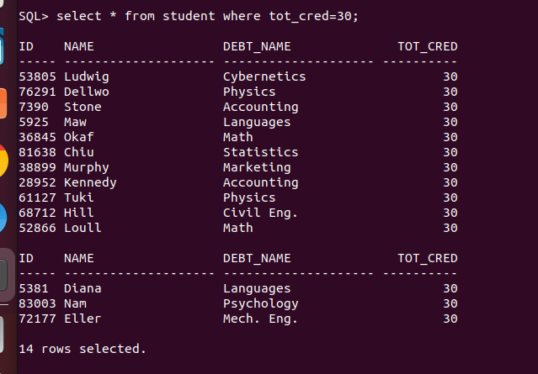

7. Find the names of all courses offered by the "Math" department.
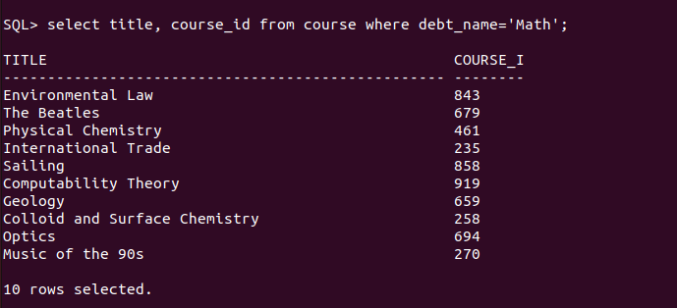
8. Retrieve the names of all instructors who earn more than ₹100,000.
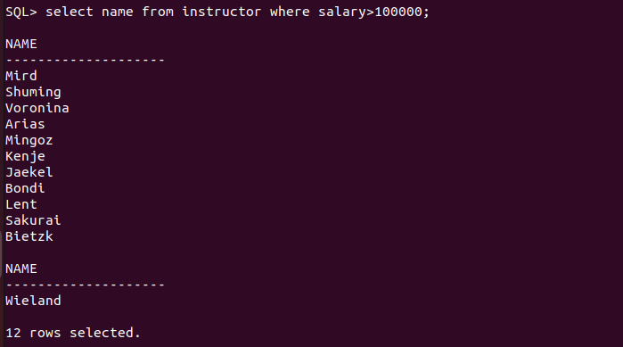
9. List all classrooms located in the "Taylor" building.

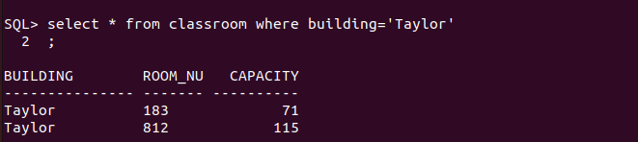
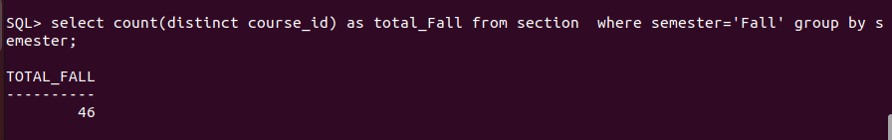
10. Find the total number of courses offered in the "Winter" semester.

11. List all students who have taken courses with a grade of "C" or lower.

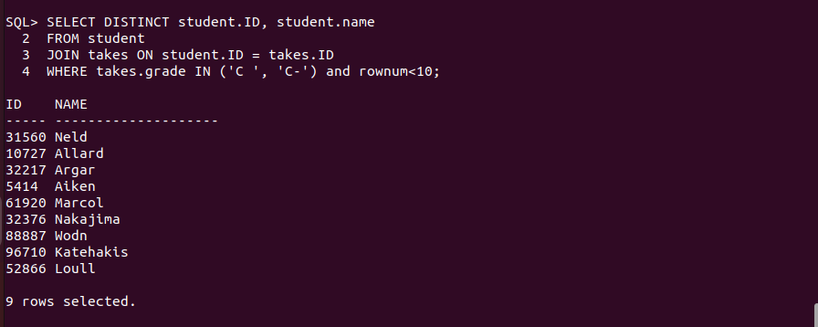
12. Retrieve the names of instructors who have taught in the "Fall" semester of 2022.
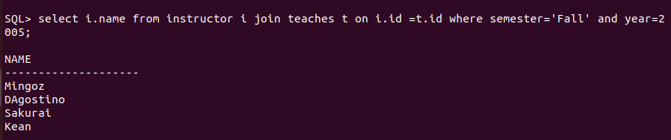

13. Find the average capacity of classrooms in each building.
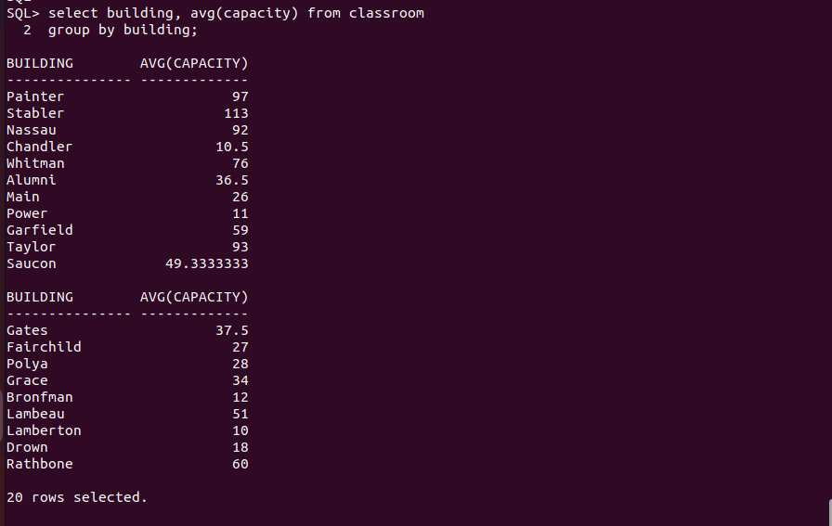

14. List all courses that have more than 3 credits.
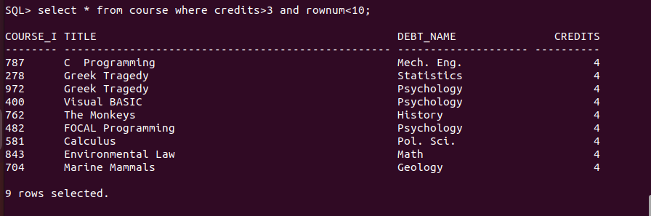
15. Retrieve the names of students who have taken courses in the "Watson" building.

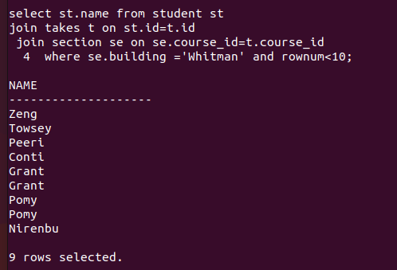

16. Find the total number of students advised by each instructor.

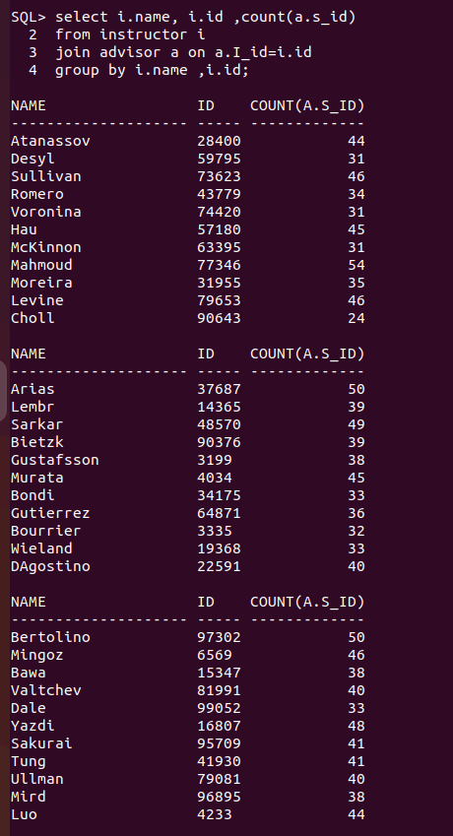
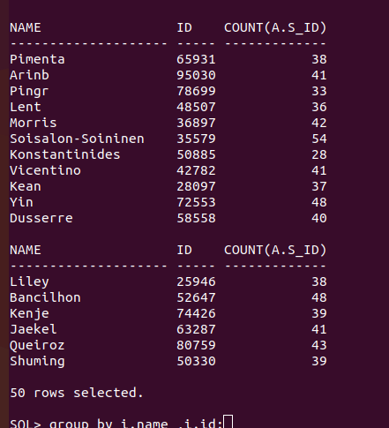

17. List all sections that do not have a classroom assigned.

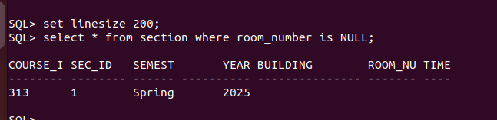

18. Retrieve the names of students who have taken courses with the highest number of
credits.

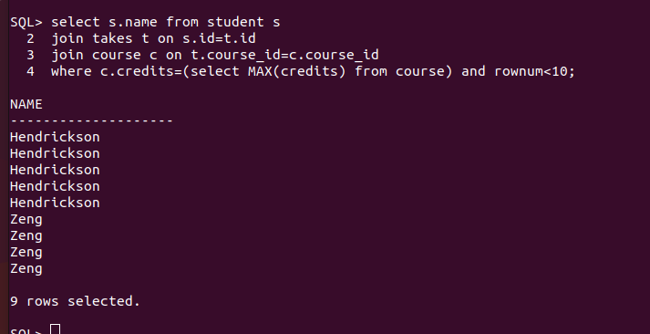
19. Find the departments with the highest average instructor salary.


20. List all courses that have been taught by more than one instructor.
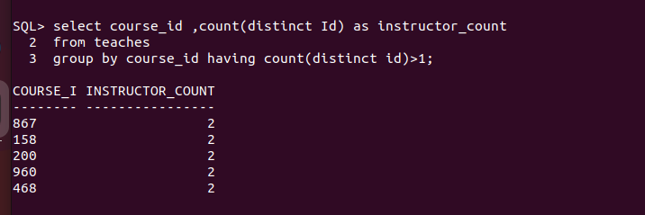

21. List all students who have taken courses with a grade of "A" in the "Fall" semester of
2022.
22. Retrieve the names of instructors who have taught in the "Spring" semester of 2023.
23. Find the average number of students enrolled in each course.
24. List all courses that have exactly 4 credits.
25. Retrieve the names of students who have taken courses in the "Packard" building.

26. Find the total number of sections taught by each instructor.

SELECT i.name, COUNT(*)
FROM instructor i
JOIN teaches t ON i.ID = t.ID
GROUP BY i.name;

27. List all sections that are held in rooms with a capacity of less than 50.

SELECT sec.course_id, sec.sec_id
FROM section sec
JOIN classroom c ON sec.building = c.building AND sec.room_number = c.room_number
WHERE c.capacity < 50;

28. Retrieve the names of students who have taken courses with the lowest number of
credits.

select s.name from student s join takes t on t.id = s.id
join course c on t.course_id=c .course_id
where c.credits=(select min(credits) from course);

29. Find the departments with the lowest average instructor salary.

SELECT dept_name
FROM instructor
GROUP BY dept_name
ORDER BY AVG(salary)
FETCH FIRST 1 ROW WITH TIES;
Or limit
30. List all courses that have been taught by only one instructor.

31. Find the students who have taken courses with every instructor in the university.

SELECT s.id, s.name
FROM student s
WHERE NOT EXISTS (
SELECT i.id
FROM instructor i
MINUS
SELECT t.instructor_id
FROM takes tk
JOIN teaches t ON tk.course_id = t.course_id
WHERE tk.id = s.id
);

32. Retrieve the names of instructors who have taught courses in all available semesters. *

SELECT i.id, i.name
FROM instructor i
WHERE NOT EXISTS (
SELECT DISTINCT semester FROM section
MINUS
SELECT DISTINCT s.semester
FROM teaches t
JOIN section s ON t.course_id = s.course_id AND t.sec_id = s.sec_id
WHERE t.instructor_id = i.id
);

33. List all courses that have been taught in every building.
SELECT c.course_id, c.title
FROM course c
WHERE NOT EXISTS (
SELECT DISTINCT building FROM section
MINUS
SELECT DISTINCT s.building
FROM section s
WHERE s.course_id = c.course_id
);

SELECT c.title
FROM course c
JOIN section s ON c.course_id = s.course_id
GROUP BY c.title
HAVING COUNT(DISTINCT s.building) = (SELECT COUNT(DISTINCT building) FROM classroom);

34. Find the students who have taken the most number of courses in a single year.

SELECT tk.id, s.name, tk.year, COUNT(*) AS course_count
FROM takes tk
JOIN student s ON tk.id = s.id
GROUP BY tk.id, s.name, tk.year
HAVING COUNT(*) = (
SELECT MAX(course_count)
FROM (SELECT id, year, COUNT(*) AS course_count
FROM takes
GROUP BY id, year)
);

SELECT s.name, t.year, COUNT(*)
FROM student s
JOIN takes t ON s.ID = t.ID
GROUP BY s.name, t.year
ORDER BY COUNT(*) DESC
FETCH FIRST 1 ROW WITH TIES;

35. Retrieve the names of students who have taken courses with overlapping time slots in the same semester.

SELECT DISTINCT s.id, s.name
FROM student s
JOIN takes t1 ON s.id = t1.id
JOIN section sec1 ON t1.course_id = sec1.course_id AND t1.sec_id = sec1.sec_id
JOIN time_slot ts1 ON sec1.time_slot_id = ts1.time_slot_id
JOIN takes t2 ON s.id = t2.id AND t1.course_id <> t2.course_id
JOIN section sec2 ON t2.course_id = sec2.course_id AND t2.sec_id = sec2.sec_id
JOIN time_slot ts2 ON sec2.time_slot_id = ts2.time_slot_id
WHERE t1.semester = t2.semester AND ts1.time_slot_id = ts2.time_slot_id;

SELECT DISTINCT s.name
FROM takes t1
JOIN takes t2 ON t1.ID = t2.ID AND t1.course_id != t2.course_id
JOIN section s1 ON t1.course_id = s1.course_id
JOIN section s2 ON t2.course_id = s2.course_id
JOIN time_slot ts1 ON s1.time_slot_id = ts1.time_slot_id
JOIN time_slot ts2 ON s2.time_slot_id = ts2.time_slot_id
WHERE t1.semester = t2.semester
AND ts1.day = ts2.day
AND (
(ts1.start_hr < ts2.end_hr OR (ts1.start_hr = ts2.end_hr AND ts1.start_min < ts2.end_min))
AND
(ts2.start_hr < ts1.end_hr OR (ts2.start_hr = ts1.end_hr AND ts2.start_min < ts1.end_min))
);

36. List all courses that have been taught by the same instructor in consecutive semesters.

SELECT DISTINCT t1.course_id, t1.instructor_id
FROM teaches t1
JOIN teaches t2 ON t1.instructor_id = t2.instructor_id
AND t1.course_id = t2.course_id
AND t1.year = t2.year - 1
AND (t1.semester = 'Fall' AND t2.semester = 'Spring');

SELECT DISTINCT t1.course_id, i.name
FROM teaches t1
JOIN teaches t2 ON t1.ID = t2.ID AND t1.course_id = t2.course_id
JOIN instructor i ON t1.ID = i.ID
WHERE (t1.year = t2.year -1 AND t1.semester = 'Fall' AND t2.semester = 'Spring')
OR (t1.semester = 'Winter' AND t2.semester = 'Spring');

37. Find the departments where the total student credits are less than the department
budget.

SELECT d.dept_name
FROM department d
JOIN student s ON d.dept_name = s.debt_name
GROUP BY d.dept_name, d.budget
HAVING SUM(s.tot_cred) < d.budget;

SELECT d.dept_name
FROM department d
JOIN student s ON d.dept_name = s.dept_name
GROUP BY d.dept_name, d.budget
HAVING SUM(s.tot_cred) < d.budget;

38. Retrieve the names of students who have taken courses with every time slot.

SELECT s.id, s.name
FROM student s
WHERE NOT EXISTS (
SELECT time_slot_id FROM time_slot
MINUS
SELECT DISTINCT sec.time_slot_id
FROM takes t
JOIN section sec ON t.course_id = sec.course_id AND t.sec_id = sec.sec_id
WHERE t.id = s.id
);

SELECT s.name
FROM student s
WHERE NOT EXISTS (
SELECT time_slot_id FROM time_slot
MINUS
SELECT DISTINCT time_slot_id
FROM takes t
JOIN section sec ON t.course_id = sec.course_id
WHERE t.ID = s.ID
);

39. List all courses that have been taught in every year.

SELECT c.course_id, c.title
FROM course c
WHERE NOT EXISTS (
SELECT DISTINCT year FROM section
MINUS
SELECT DISTINCT s.year
FROM section s
WHERE s.course_id = c.course_id
);

SELECT course_id
FROM section
GROUP BY course_id
HAVING COUNT(DISTINCT year) = (SELECT COUNT(DISTINCT year) FROM section);

40. Find the students who have taken the most number of courses with the same instructor.

SELECT t.id, s.name, t.instructor_id, COUNT(*) AS course_count
FROM takes t
JOIN student s ON t.id = s.id
GROUP BY t.id, s.name, t.instructor_id
HAVING COUNT(*) = (
SELECT MAX(course_count)
FROM (SELECT id, instructor_id, COUNT(*) AS course_count
FROM takes
GROUP BY id, instructor_id)
);

SELECT s.name, te.ID, COUNT(*)
FROM student s
JOIN takes t ON s.ID = t.ID
JOIN teaches te ON t.course_id = te.course_id
GROUP BY s.name, te.ID
ORDER BY COUNT(*) DESC
FETCH FIRST 1 ROW WITH TIES;

41. Find the students who have taken courses from at least 3 different departments.

SELECT t.id, s.name
FROM takes t
JOIN section sec ON t.course_id = sec.course_id
JOIN course c ON sec.course_id = c.course_id
GROUP BY t.id, s.name
HAVING COUNT(DISTINCT c.dept_name) >= 3;

SELECT s.name
FROM student s
JOIN takes t ON s.ID = t.ID
JOIN course c ON t.course_id = c.course_id
GROUP BY s.name
HAVING COUNT(DISTINCT c.dept_name) >= 3;

42. Retrieve the names of instructors who have taught the same course in consecutive
years.

SELECT DISTINCT t1.instructor_id, i.name
FROM teaches t1
JOIN teaches t2 ON t1.course_id = t2.course_id
AND t1.instructor_id = t2.instructor_id
AND t1.year = t2.year - 1
JOIN instructor i ON t1.instructor_id = i.id;

SELECT i.name, t1.course_id
FROM teaches t1
JOIN teaches t2 ON t1.ID = t2.ID AND t1.course_id = t2.course_id
JOIN instructor i ON t1.ID = i.ID
WHERE t2.year = t1.year + 1;

43. List all courses that are prerequisites for exactly 2 other courses.

SELECT p.course_id
FROM prereq p
GROUP BY p.course_id
HAVING COUNT(DISTINCT p.prereq_id) = 2;

SELECT prereq_id
FROM prereq
GROUP BY prereq_id
HAVING COUNT(*) = 2;

44. Find the departments where the total student credits are equal to the department budget.

SELECT d.dept_name
FROM department d
JOIN student s ON d.dept_name = s.debt_name
GROUP BY d.dept_name, d.budget
HAVING SUM(s.tot_cred) = d.budget;

45. Retrieve the names of students who have taken courses with every time slot in a single
semester.

SELECT s.id, s.name
FROM student s
WHERE NOT EXISTS (
SELECT time_slot_id FROM time_slot
MINUS
SELECT DISTINCT sec.time_slot_id
FROM takes t
JOIN section sec ON t.course_id = sec.course_id AND t.sec_id = sec.sec_id
WHERE t.id = s.id AND t.semester = 'Fall'
);

SELECT s.name, t.semester, t.year
FROM student s
JOIN takes t ON s.ID = t.ID
JOIN section sec ON t.course_id = sec.course_id
GROUP BY s.name, t.semester, t.year
HAVING COUNT(DISTINCT sec.time_slot_id) = (SELECT COUNT(DISTINCT time_slot_id) FROM time_slot);

46. List all courses that have been taught in every building except one.

SELECT c.course_id, c.title
FROM course c
WHERE (
SELECT COUNT(DISTINCT s.building)
FROM section s
WHERE s.course_id = c.course_id
) = (SELECT COUNT(DISTINCT building) FROM section) - 1;

47. Find the students who have taken the most number of courses in a single department.

SELECT t.id, s.name, c.dept_name, COUNT(*) AS course_count
FROM takes t
JOIN section sec ON t.course_id = sec.course_id
JOIN course c ON sec.course_id = c.course_id
JOIN student s ON t.id = s.id
GROUP BY t.id, s.name, c.dept_name
HAVING COUNT(*) = (
SELECT MAX(course_count)
FROM (SELECT id, dept_name, COUNT(*) AS course_count
FROM takes
JOIN section USING(course_id)
JOIN course USING(course_id)
GROUP BY id, dept_name)
);

SELECT s.name, c.dept_name, COUNT(*)
FROM student s
JOIN takes t ON s.ID = t.ID
JOIN course c ON t.course_id = c.course_id
GROUP BY s.name, c.dept_name
ORDER BY COUNT(*) DESC
FETCH FIRST 1 ROW WITH TIES;

48. Retrieve the names of instructors who have taught courses in all available time slots.

SELECT i.id, i.name
FROM instructor i
WHERE NOT EXISTS (
SELECT time_slot_id FROM time_slot
MINUS
SELECT DISTINCT s.time_slot_id
FROM teaches t
JOIN section s ON t.course_id = s.course_id AND t.sec_id = s.sec_id
WHERE t.instructor_id = i.id
);

SELECT i.name
FROM instructor i
JOIN teaches t ON i.ID = t.ID
JOIN section sec ON t.course_id = sec.course_id
GROUP BY i.name
HAVING COUNT(DISTINCT sec.time_slot_id) = (SELECT COUNT(DISTINCT time_slot_id) FROM time_slot);

49. List all students who have taken courses with overlapping time slots in different
semesters.

SELECT DISTINCT s.id, s.name
FROM student s
JOIN takes t1 ON s.id = t1.id
JOIN section sec1 ON t1.course_id = sec1.course_id AND t1.sec_id = sec1.sec_id
JOIN time_slot ts1 ON sec1.time_slot_id = ts1.time_slot_id
JOIN takes t2 ON s.id = t2.id AND t1.semester <> t2.semester
JOIN section sec2 ON t2.course_id = sec2.course_id AND t2.sec_id = sec2.sec_id
JOIN time_slot ts2 ON sec2.time_slot_id = ts2.time_slot_id
WHERE ts1.time_slot_id = ts2.time_slot_id;

SELECT DISTINCT s.name
FROM takes t1
JOIN takes t2 ON t1.ID = t2.ID AND t1.course_id != t2.course_id
JOIN section s1 ON t1.course_id = s1.course_id
JOIN section s2 ON t2.course_id = s2.course_id
JOIN time_slot ts1 ON s1.time_slot_id = ts1.time_slot_id
JOIN time_slot ts2 ON s2.time_slot_id = ts2.time_slot_id
WHERE t1.semester != t2.semester
AND ts1.day = ts2.day
AND (
(ts1.start_hr < ts2.end_hr OR (ts1.start_hr = ts2.end_hr AND ts1.start_min < ts2.end_min))
AND
(ts2.start_hr < ts1.end_hr OR (ts2.start_hr = ts1.end_hr AND ts2.start_min < ts1.end_min))
);

50. Find the courses that have the lowest enrollment across all semesters.

SELECT t.course_id, c.title, COUNT(*) AS enrollment
FROM takes t
JOIN course c ON t.course_id = c.course_id
GROUP BY t.course_id, c.title
HAVING COUNT(*) = (
SELECT MIN(course_count)
FROM (SELECT course_id, COUNT(*) AS course_count
FROM takes
GROUP BY course_id)
);

SELECT course_id
FROM takes
GROUP BY course_id
ORDER BY COUNT(*)
FETCH FIRST 1 ROW WITH TIES;

